|  |  |  |
| --- | --- | --- |
| **DEVOPS TRAINING** | | |
| **automated code analysis** | | |
| Author: | Aleksandr Merkushkin  [Alexander_Merkuhkin@epam.com](mailto:Alexander_Merkuhkin@epam.com) |
| Mentor: | Alexey Pankratov  [Alexey_Pankratov@epam.com](mailto:Alexey_Pankratov@epam.com) |
| Date: 04.02.2021 |  |

**Contents**

Tasks…………………………………………………………………………………………………………………….3

Task 1. Automated Code Analysis.….………………………………………….……………………..…4

# Task 1. Automated Code Analysis

# Review

Public Java-based project will be setup in Jenkins job with Sonar analysis

# Task

1. Install and configure PostrgeSQL
2. Install and configure Sonar server
3. Configure Sonar with Nginx, so that it accessible via http://sonar
4. Configure Sonar security – limit anonymous access to instance
5. Configure Jenkins for Sonar analysis
6. Create Sonar analysis profile and add/modify/remove a couple of rules. Set is as the default profile
7. Choose some open-source project for building with Jenkins and create a regular build job (build-principals/src…)
8. Add Sonar analysis in Jenkins job configuration.
9. Add some lines in the code and Run configured job several times to see the difference
10. Prove by screenshots of dashboards

Email pattern: [MNT-CD-6]-FirstName-LastName

**Task 1**

**Automated Code Analysis**

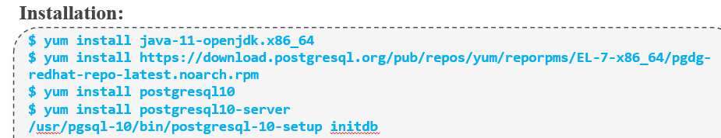

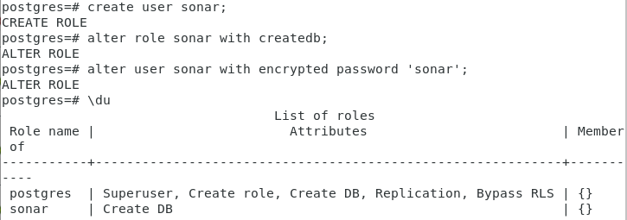

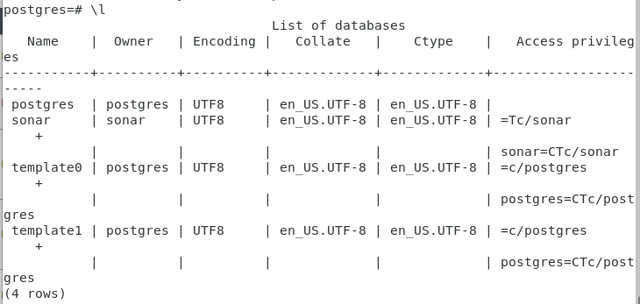

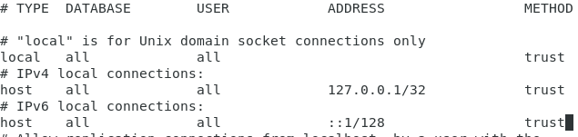

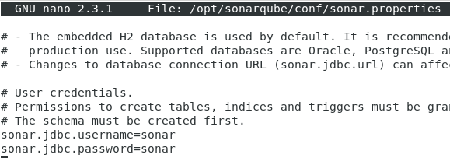





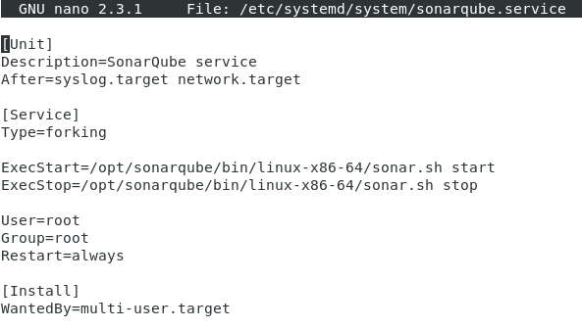

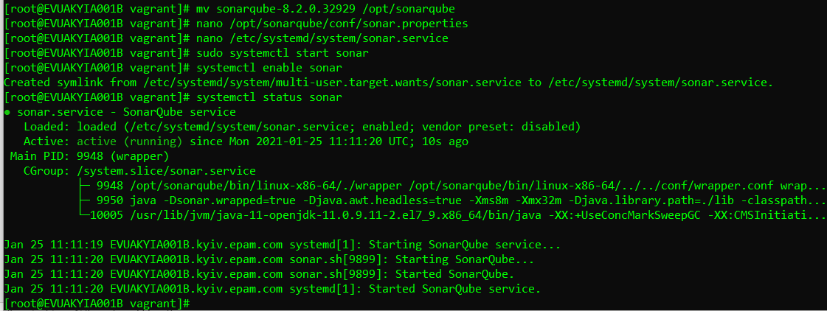

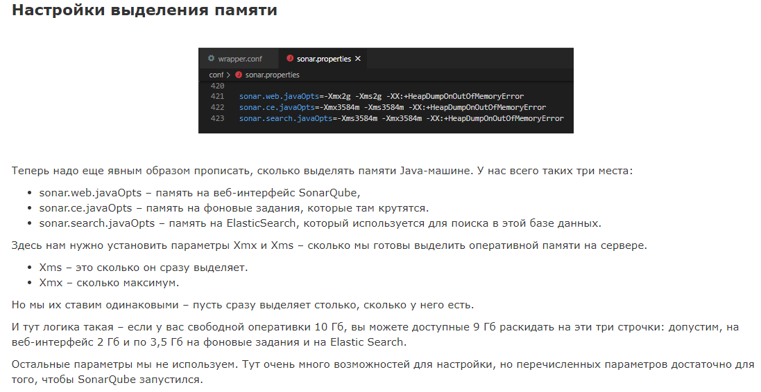



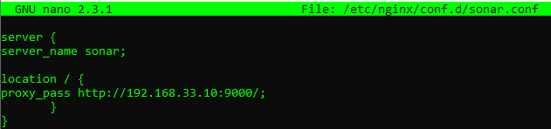

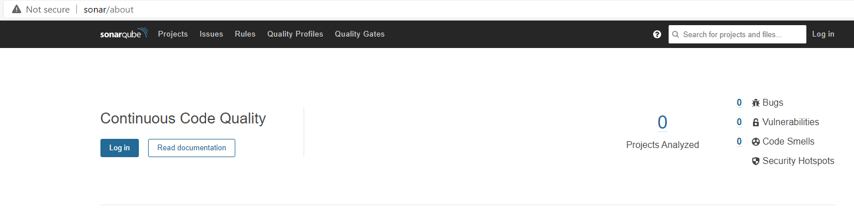

**Hosts** 

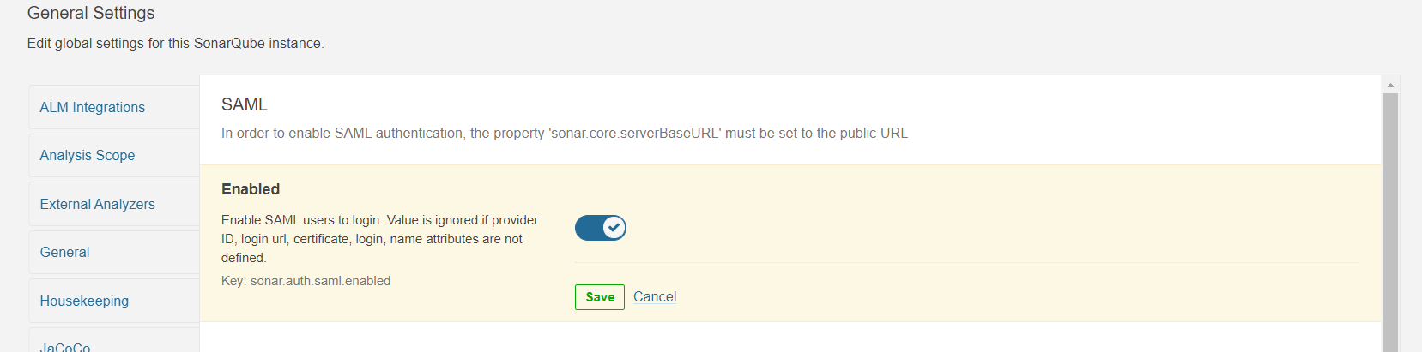

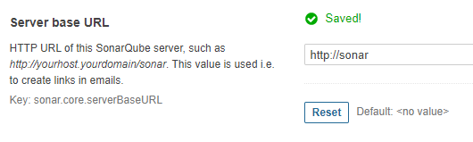

**Wget** [**https://github.com/SonarSource/sonar-scanner-cli/releases/download/4.4.0.2170/sonar-scanner-cli-4.4.0.2170-linux.zip**](https://github.com/SonarSource/sonar-scanner-cli/releases/download/4.4.0.2170/sonar-scanner-cli-4.4.0.2170-linux.zip)

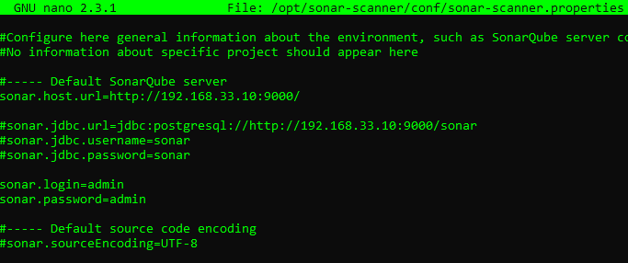

**chmod +x /opt/sonar-scanner/bin/sonar-scanner**

**ln -s /opt/sonar-scanner/bin/sonar-scanner /usr/local/bin/sonar-scanner**

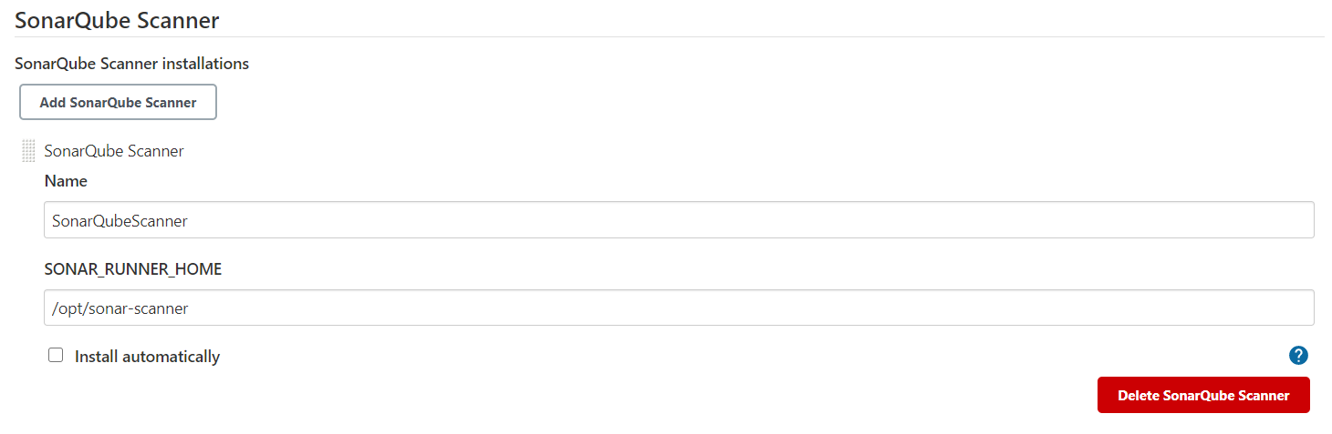

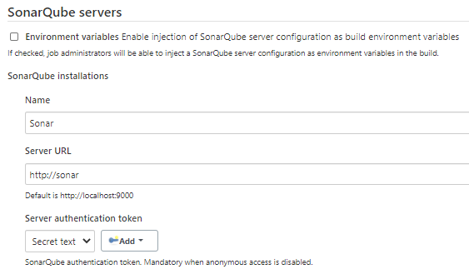

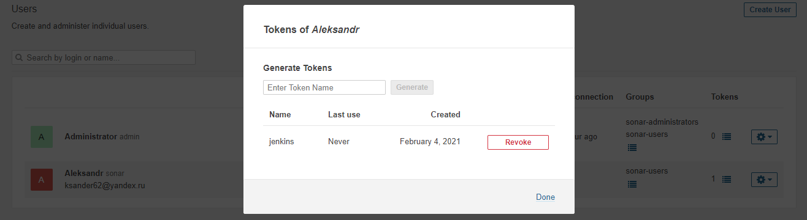

**Токен в secret**

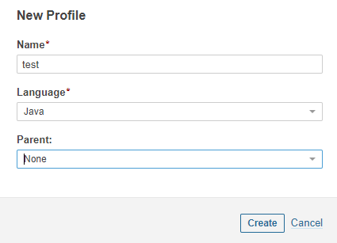

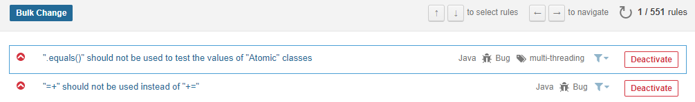

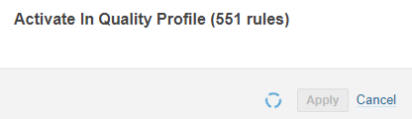

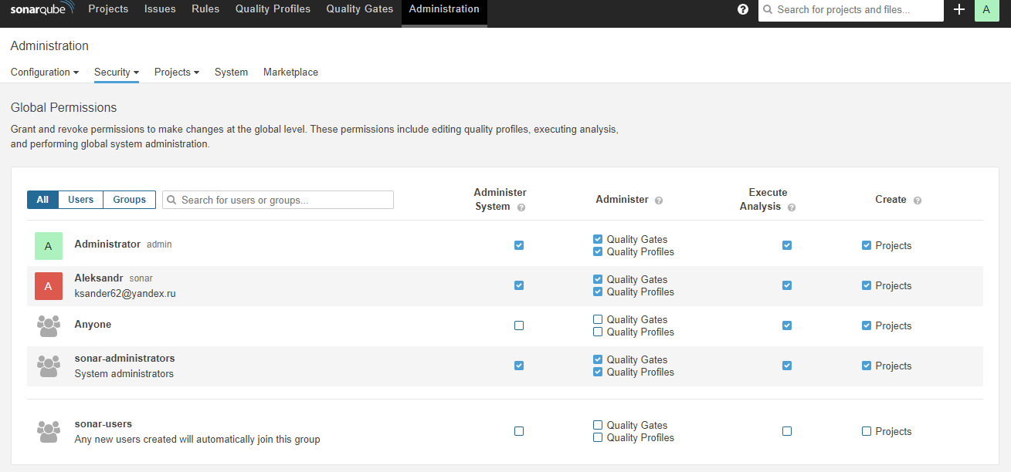

**В Jenkins**

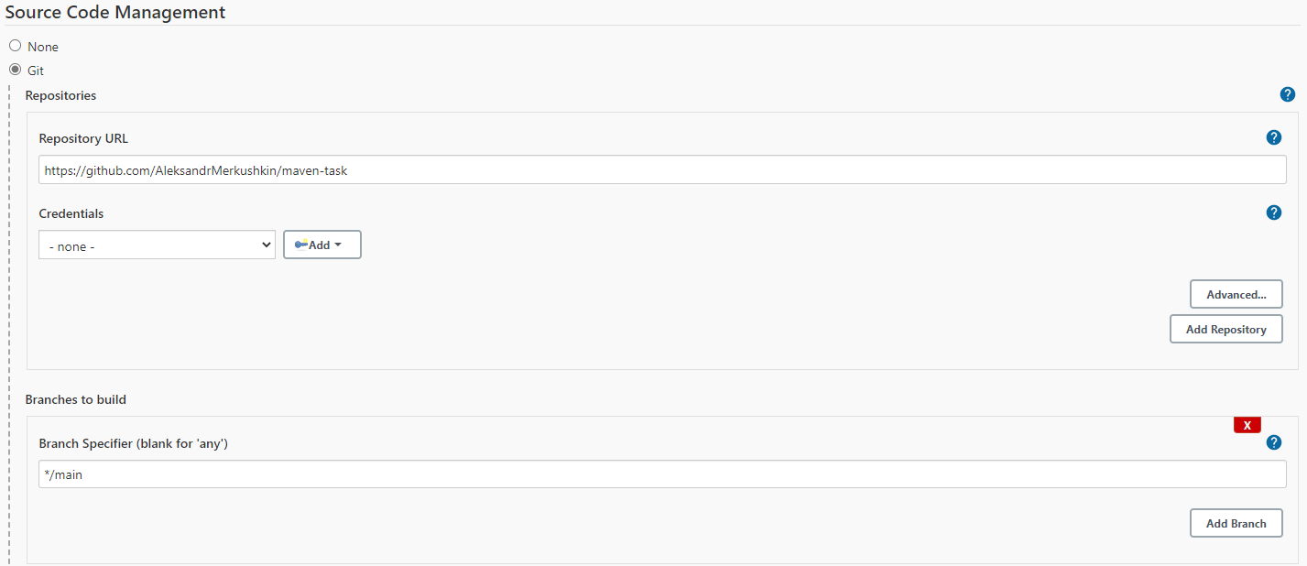

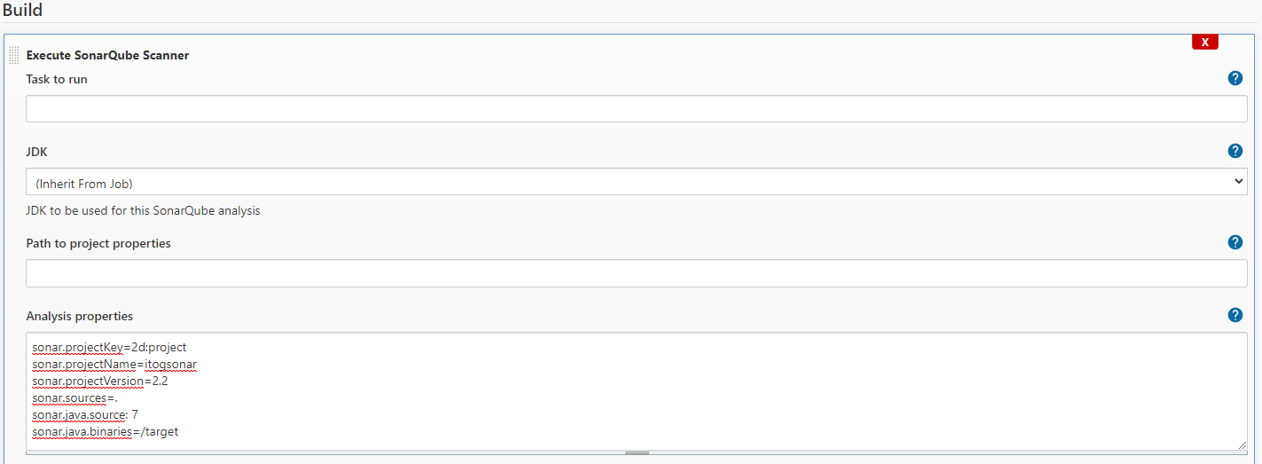

sonar.projectKey=2d:project

sonar.projectName=itogsonar

sonar.projectVersion=2.2

sonar.sources=.

sonar.java.source: 7

sonar.java.binaries=/target

**Console output**

Started by user [Aleksandr](http://jenkins/user/aleksandr)

Running as SYSTEM

Building on master in workspace /var/lib/jenkins/workspace/sonarqube

The recommended git tool is: NONE

No credentials specified

> git rev-parse --is-inside-work-tree # timeout=10

Fetching changes from the remote Git repository

> git config remote.origin.url <https://github.com/AleksandrMerkushkin/maven-task> # timeout=10

Fetching upstream changes from <https://github.com/AleksandrMerkushkin/maven-task>

> git --version # timeout=10

> git --version # 'git version 1.8.3.1'

> git fetch --tags --progress <https://github.com/AleksandrMerkushkin/maven-task> +refs/heads/*:refs/remotes/origin/* # timeout=10

> git rev-parse refs/remotes/origin/main^{commit} # timeout=10

Checking out Revision d52edfb58dc442c3265763d762ee261ebfc2ce27 (refs/remotes/origin/main)

> git config core.sparsecheckout # timeout=10

> git checkout -f d52edfb58dc442c3265763d762ee261ebfc2ce27 # timeout=10

Commit message: "Update pom.xml"

> git rev-list --no-walk d52edfb58dc442c3265763d762ee261ebfc2ce27 # timeout=10

[sonarqube] $ /opt/sonar-scanner/bin/sonar-scanner -Dsonar.host.url=<http://sonar/> -Dsonar.projectKey=2d:project -Dsonar.projectName=itogsonar -Dsonar.projectVersion=2.2 -Dsonar.java.source=7 -Dsonar.sources=. -Dsonar.java.binaries=/target -Dsonar.projectBaseDir=/var/lib/jenkins/workspace/sonarqube

INFO: Scanner configuration file: /opt/sonar-scanner/conf/sonar-scanner.properties

INFO: Project root configuration file: NONE

INFO: SonarScanner 4.4.0.2170

INFO: Java 11.0.3 AdoptOpenJDK (64-bit)

INFO: Linux 3.10.0-1160.11.1.el7.x86_64 amd64

INFO: User cache: /var/lib/jenkins/.sonar/cache

INFO: Scanner configuration file: /opt/sonar-scanner/conf/sonar-scanner.properties

INFO: Project root configuration file: NONE

INFO: Analyzing on SonarQube server 8.2.0

INFO: Default locale: "en_US", source code encoding: "UTF-8" (analysis is platform dependent)

INFO: Load global settings

INFO: Load global settings (done) | time=363ms

INFO: Server id: A7EE8CF2-AXc9_gSKQy6TDr-Co1nK

INFO: User cache: /var/lib/jenkins/.sonar/cache

INFO: Load/download plugins

INFO: Load plugins index

INFO: Load plugins index (done) | time=363ms

INFO: Load/download plugins (done) | time=627ms

INFO: Process project properties

INFO: Process project properties (done) | time=15ms

INFO: Execute project builders

INFO: Execute project builders (done) | time=2ms

INFO: Project key: 2d:project

INFO: Base dir: /var/lib/jenkins/workspace/sonarqube

INFO: Working dir: /var/lib/jenkins/workspace/sonarqube/.scannerwork

INFO: Load project settings for component key: '2d:project'

INFO: Load project settings for component key: '2d:project' (done) | time=377ms

INFO: Load quality profiles

INFO: Load quality profiles (done) | time=362ms

INFO: Detected Jenkins

INFO: Load active rules

INFO: Load active rules (done) | time=7007ms

INFO: Indexing files...

INFO: Project configuration:

INFO: 15 files indexed

INFO: 0 files ignored because of scm ignore settings

INFO: Quality profile for java: test

INFO: Quality profile for xml: Sonar way

INFO: ------------- Run sensors on module itogsonar

INFO: Load metrics repository

INFO: Load metrics repository (done) | time=409ms

WARNING: An illegal reflective access operation has occurred

WARNING: Illegal reflective access by net.sf.cglib.core.ReflectUtils$1 (file:/var/lib/jenkins/.sonar/cache/54f6535c111cefad0fb6a09ba3e61922/sonar-javascript-plugin.jar) to method java.lang.ClassLoader.defineClass(java.lang.String,byte[],int,int,java.security.ProtectionDomain)

WARNING: Please consider reporting this to the maintainers of net.sf.cglib.core.ReflectUtils$1

WARNING: Use --illegal-access=warn to enable warnings of further illegal reflective access operations

WARNING: All illegal access operations will be denied in a future release

INFO: Sensor JavaSquidSensor [java]

INFO: Configured Java source version (sonar.java.source): 7

INFO: JavaClasspath initialization

WARN: Bytecode of dependencies was not provided for analysis of source files, you might end up with less precise results. Bytecode can be provided using sonar.java.libraries property.

INFO: JavaClasspath initialization (done) | time=125ms

INFO: JavaTestClasspath initialization

INFO: JavaTestClasspath initialization (done) | time=0ms

INFO: Java Main Files AST scan

INFO: 2 source files to be analyzed

INFO: Load project repositories

INFO: Load project repositories (done) | time=876ms

INFO: Java Main Files AST scan (done) | time=4259ms

INFO: Java Test Files AST scan

INFO: 0 source files to be analyzed

INFO: Java Test Files AST scan (done) | time=11ms

INFO: Sensor JavaSquidSensor [java] (done) | time=4878ms

INFO: Sensor SonarCSS Rules [cssfamily]

INFO: No CSS, PHP, HTML or VueJS files are found in the project. CSS analysis is skipped.

INFO: Sensor SonarCSS Rules [cssfamily] (done) | time=1ms

INFO: Sensor JaCoCo XML Report Importer [jacoco]

INFO: 2/2 source files have been analyzed

INFO: 0/0 source files have been analyzed

INFO: Sensor JaCoCo XML Report Importer [jacoco] (done) | time=3ms

INFO: Sensor SurefireSensor [java]

INFO: parsing [/var/lib/jenkins/workspace/sonarqube/target/surefire-reports]

INFO: Sensor SurefireSensor [java] (done) | time=48ms

INFO: Sensor JavaXmlSensor [java]

INFO: 2 source files to be analyzed

INFO: Sensor JavaXmlSensor [java] (done) | time=666ms

INFO: Sensor HTML [web]

INFO: 2/2 source files have been analyzed

INFO: Sensor HTML [web] (done) | time=20ms

INFO: Sensor XML Sensor [xml]

INFO: 2 source files to be analyzed

INFO: Sensor XML Sensor [xml] (done) | time=265ms

INFO: 2/2 source files have been analyzed

INFO: ------------- Run sensors on project

INFO: Sensor Zero Coverage Sensor

INFO: Sensor Zero Coverage Sensor (done) | time=118ms

INFO: Sensor Java CPD Block Indexer

INFO: Sensor Java CPD Block Indexer (done) | time=109ms

INFO: CPD Executor 2 files had no CPD blocks

INFO: CPD Executor Calculating CPD for 0 files

INFO: CPD Executor CPD calculation finished (done) | time=0ms

INFO: Analysis report generated in 440ms, dir size=99 KB

INFO: Analysis report compressed in 92ms, zip size=19 KB

INFO: Analysis report uploaded in 621ms

INFO: ANALYSIS SUCCESSFUL, you can browse <http://sonar/dashboard?id=2d%3Aproject>

INFO: Note that you will be able to access the updated dashboard once the server has processed the submitted analysis report

INFO: More about the report processing at <http://sonar/api/ce/task?id=AXe1Jl8pyrwbz1mZJQ87>

INFO: Analysis total time: 21.727 s

INFO: ------------------------------------------------------------------------

INFO: EXECUTION SUCCESS

INFO: ------------------------------------------------------------------------

INFO: Total time: 24.632s

INFO: Final Memory: 16M/58M

INFO: ------------------------------------------------------------------------

Finished: SUCCESS

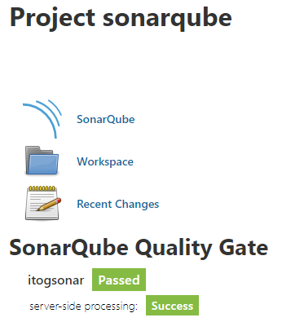

**Изначальный код**

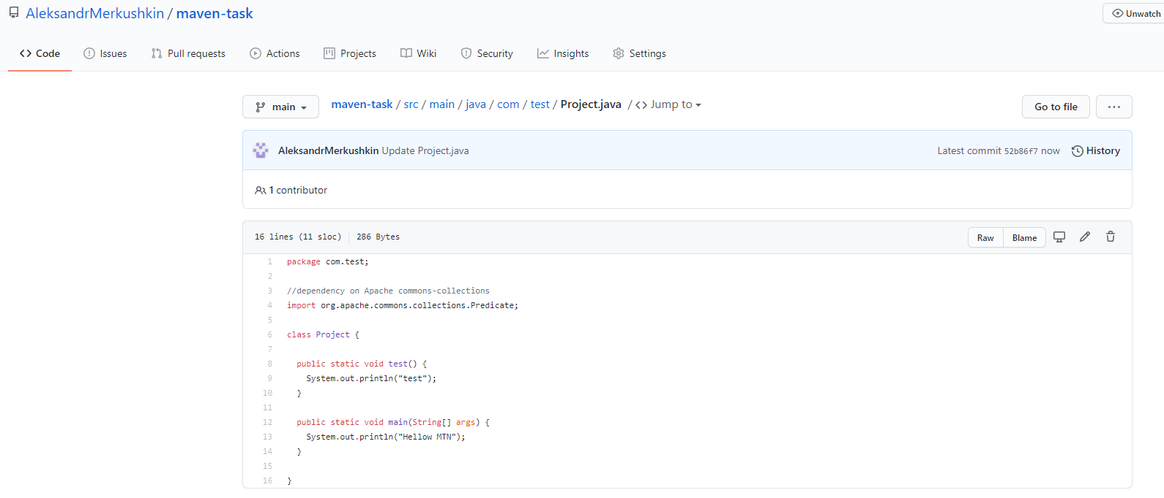

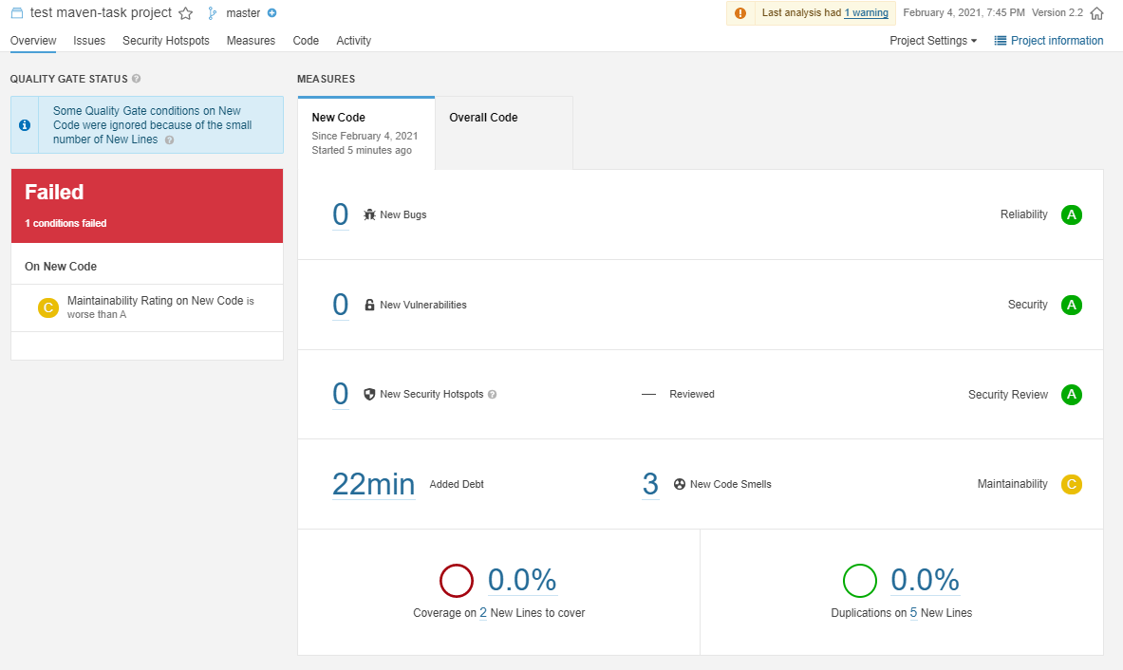

**После изменений кода №1**

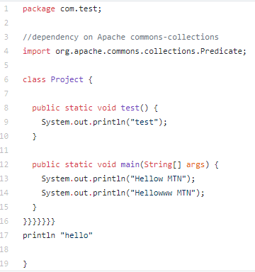

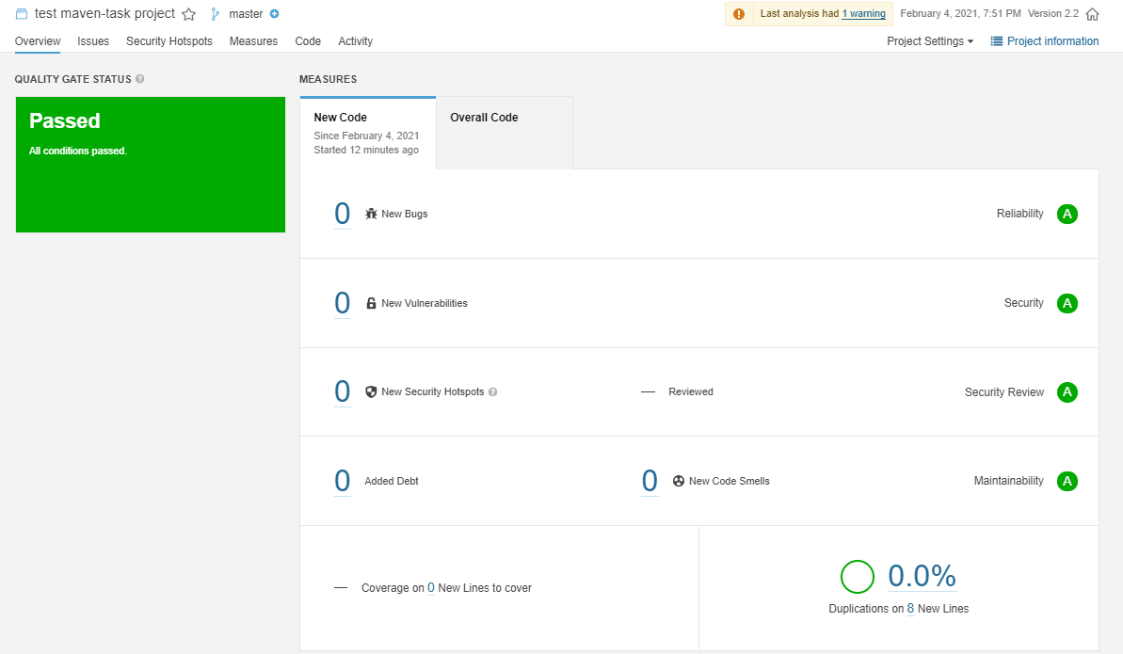

**После изменений кода №2**

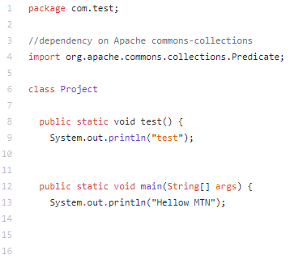

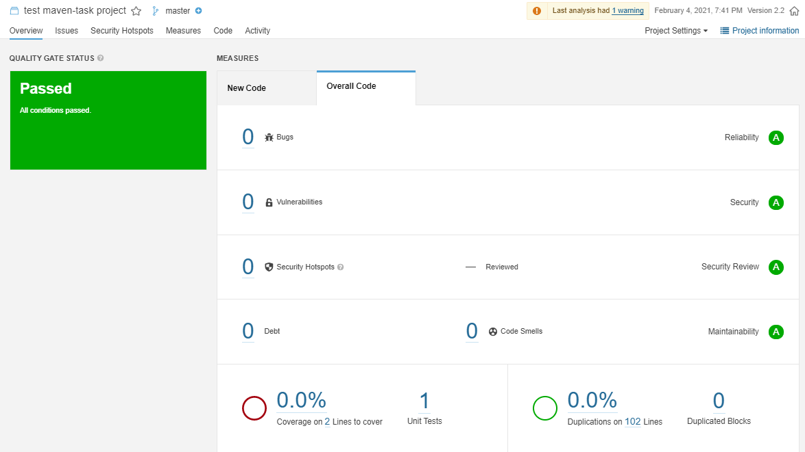

**Если запускать через консоль**

